Purpose:

This document outlines the method used to account for storage tank emissions that may not completely route to their intended control devices to incorporate in the updated 2017 Uinta Basin Emission Inventory (UBEI2017-Update, v.88).

Background:

The Uinta Basin Oil & Gas Emission Inventory (UBEI) is made up of two main components: (1) Operator Workbooks where operators provide prescribed data elements and emission estimates, and (2) Gap-Filling for emissions sources not covered in the Operator Workbooks. The emission estimates in the Operator Workbooks include emissions from storage tanks at production facilities. Tank emissions are estimated with software or GOR factors derived from sampling which assume equipment is functioning as intended. There are 8,001 production facilities in the UBEI2017-Update. Of those, 1,265 production facilities report tanks whose emissions are routed to control devices where Operators reduce the estimated tank emissions by 95-98%, mostly through the use of combustors.

EPA has observed wide spread instances of storage tank emissions not making it to their intended control devices. A description of these findings along with detailed design and operation and maintenance considerations on the tank vapor capture system were provided in a compliance alert[1] issued in September 2015. Studies and inspection observations conducted in the Uinta Basin have identified a similar prevalence as summarized in Table 1.

**Table 1.** Uinta Basin Studies and Observations on Controlled Tank Emissions

|  |  |  |  |
| --- | --- | --- | --- |
| **Study**  **Inspection** | **% Sites w/ Controlled Tanks Emitting** | **Year** | **# Sites Surveyed** |
| STEPP - Storage Tank Emissions Pilot Project[2] | 39% | 2016 | 454 |
| Aerial & Ground IR Survey[3] | 31% | 2018 | 517 |
| EPA Inspections | 47% | 2018 | 88 |

## Method:

1. From Uinta Basin specific studies and field observations in Table 1, and to be conservative, assume that 30% of the production facilities with controlled tanks experience emissions not making it to their intended control device.
2. From the UBEI2017-Update (v.88), select wellpads with Controlled tanks in Uintah & Duchesne counties.
3. From these data 30% were randomly selected to be malfunctioning.
4. For these selected facilities their controlled emissions were replaced with uncontrolled emissions which was based on their reported control percent.
5. Step 2 and 3 were repeated 10000 times as part of a monte carlo simulation.
6. From these resultant values the controlled VOC values were subtracted so as to only have those extra emissions what would have come from a malfunctioning system.

## Results:

We found that in the 10,000 run monte carlo simulation that our mean extra VOC emissions that would be generated from storage tank emissions not making it to their intended control device would be 15,040 ± 2216 tons per year (tpy) VOCs (Figure 1). We propose adding a ‘Gap-Filling’ line item to the 2017 UBEI to account for storage tank emissions not making it to their intended control devices.

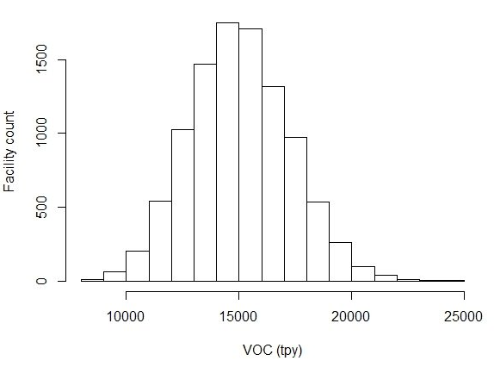

**Figure 1.** Histogram of the 10,000 run Monte Carlo simulation

1. “EPA Observes Emissions from Controlled Storage Vessels at Onshore Oil and Natural Gas Production Facilities” September 2015. <https://www.epa.gov/sites/production/files/2015-09/documents/oilgascompliancealert.pdf>
2. “STORAGE TANK EMISSIONS PILOT PROJECT (STEPP): FUGITIVE ORGANIC COMPOUND EMISSIONS FROM LIQUID STORAGE TANKS IN THE UINTA BASIN” Final Report to The Utah State Legislature, July 17, 2017. USU, TriCounty Health Dept, UDAQ. <https://documents.deq.utah.gov/air-quality/planning/technical-analysis/research/oil-and-gas/DAQ-2017-014389.pdf>
3. “Hydrocarbon Emission Detection Survey of Uinta Basin Oil and Gas Wells”. November 2018. Bingham Research Center, Utah State University. <https://usu.box.com/s/y3njm7wulu2gr4ff8itdsismmud2rxf8>